A Totally Rubbish Database I Inherited Which I Am Trying To Improve Upon

Form [OPS-CONSOLE:]
When far left controls [OPS]![Application] are clicked:
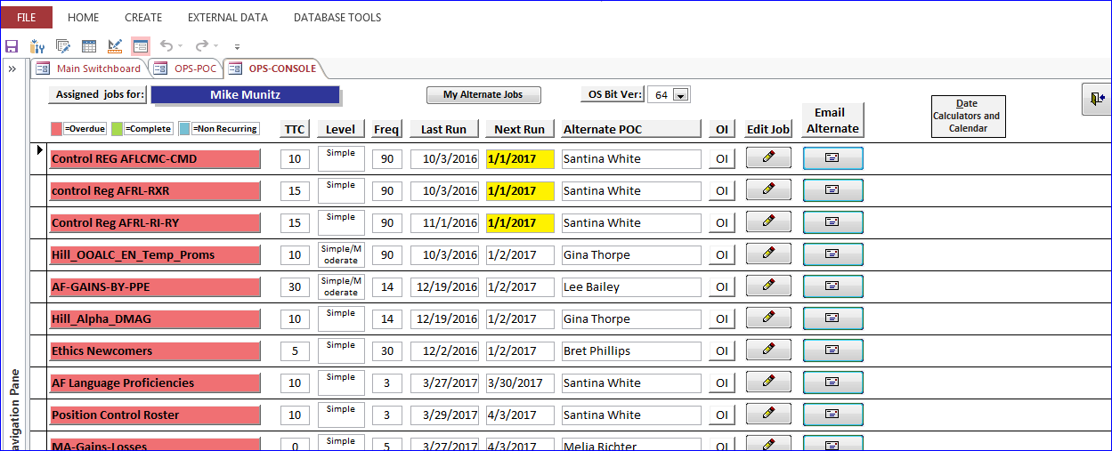

The On Click Event Procedure runs Private Sub [Application] up to a point at which a message box is delivered:
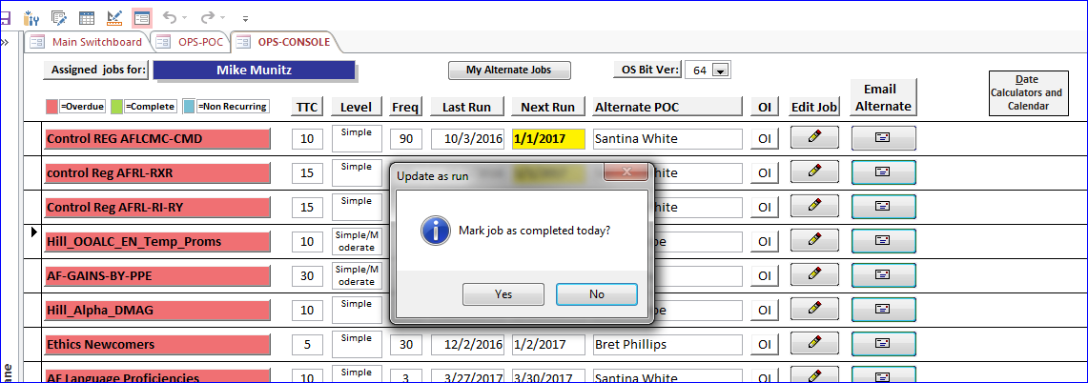

When the user clicks Yes, I would like the code to then force the user to enter a date in the field [OPS]![Application_Last], indicated by label [Last Run] in the picture above.

Here is where I would like the code to go if possible:
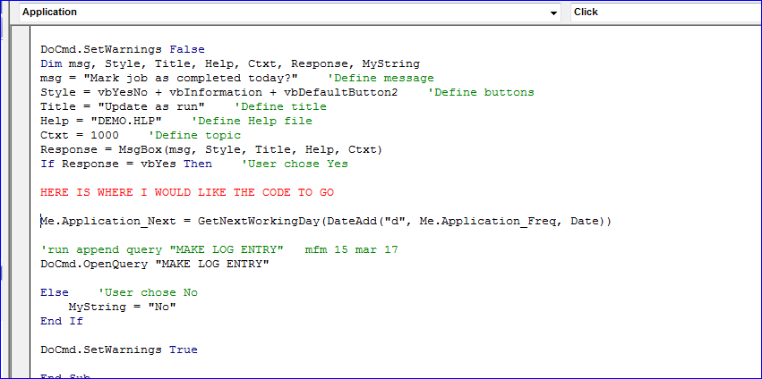
The reason I need the users to be forced to enter a date in [OPS]![Application_Last] after clicking Yes is because the next step in the event calls the function [GetNextWorkingDay], which adds the number of days in [OPS]![Application_Freq] to the date in [OPS]![Application_Last] and calculates/delivers the next run date in [OPS]![Application_Next].
The function [GetNextWorkingDay] works fine. However, users tend to get lazy with their date entry in [OPS]![Application_Last], thus creating invalid dates being calculated/delivered in [OPS]![Application_Next].

