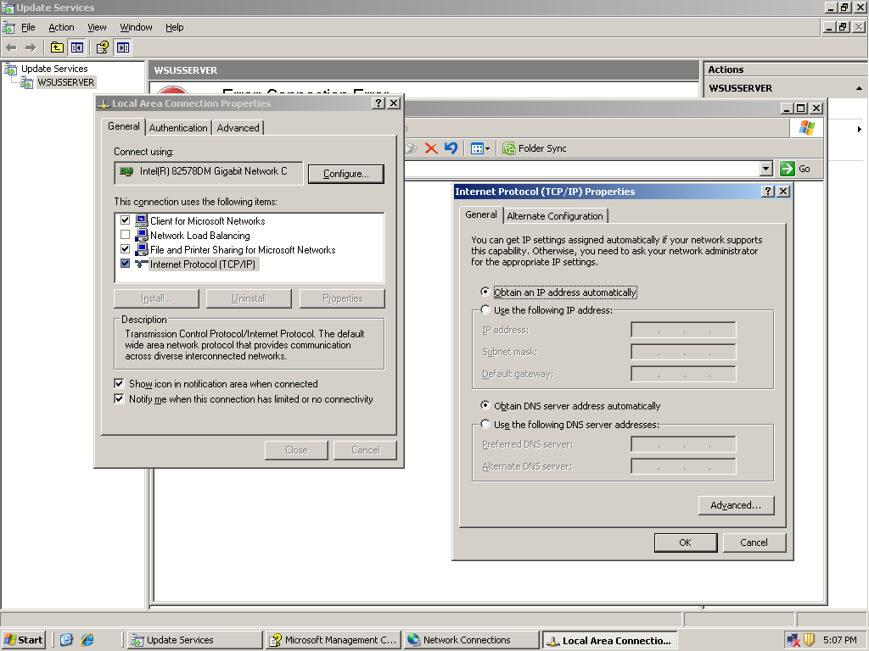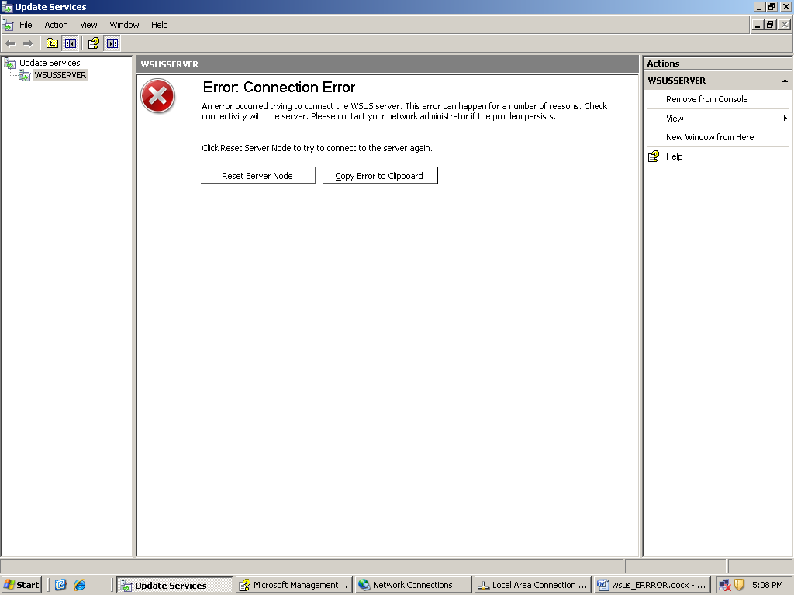

The WSUS administration console was unable to connect to the WSUS Server via the remote API.

Verify that the Update Services service, IIS and SQL are running on the server. If the problem persists, try restarting IIS, SQL, and the Update Services Service.

System.Net.WebException -- The request failed with HTTP status 400: Bad Request.

Source
System.Web.Services

Stack Trace:
at System.Web.Services.Protocols.SoapHttpClientProtocol.ReadResponse(SoapClientMessage message, WebResponse response, Stream responseStream, Boolean asyncCall)
at System.Web.Services.Protocols.SoapHttpClientProtocol.Invoke(String methodName, Object[] parameters)
at Microsoft.UpdateServices.Internal.ApiRemoting.ExecuteSPGetConfiguration()
at Microsoft.UpdateServices.Internal.DatabaseAccess.AdminDataAccessProxy.ExecuteSPGetConfiguration()
at Microsoft.UpdateServices.Internal.BaseApi.UpdateServerConfiguration.Load()
at Microsoft.UpdateServices.Internal.BaseApi.UpdateServerConfiguration..ctor(UpdateServer updateServer)
at Microsoft.UpdateServices.Internal.ClassFactory.CreateWellKnownType(Type type, Object[] args)
at Microsoft.UpdateServices.Internal.ClassFactory.CreateInstance(Type type, Object[] args)
at Microsoft.UpdateServices.Internal.BaseApi.UpdateServer.GetConfiguration()
at Microsoft.UpdateServices.UI.AdminApiAccess.CachedUpdateServerConfiguration.GetFreshObjectForCache()
at Microsoft.UpdateServices.UI.AdminApiAccess.CachedObject.RefreshCache()
at Microsoft.UpdateServices.UI.AdminApiAccess.CachedObject.GetFromCache()
at Microsoft.UpdateServices.UI.AdminApiAccess.CachedUpdateServerConfiguration.GetFromCache()
at Microsoft.UpdateServices.UI.AdminApiAccess.PermissionsManager.IsPermitted(UserOperation operation)
at Microsoft.UpdateServices.UI.AdminApiAccess.AdminApiTools.IsPermitted(UserOperation operation)
at Microsoft.UpdateServices.UI.SnapIn.Scope.UpdatesSummaryScopeNode.RefreshPermissions()
at Microsoft.UpdateServices.UI.SnapIn.Scope.UpdatesSummaryScopeNode..ctor(ServerTools serverTools)
at Microsoft.UpdateServices.UI.SnapIn.Scope.ServerSummaryScopeNode.AddChildNodes()
at Microsoft.UpdateServices.UI.SnapIn.Scope.ServerSummaryScopeNode.ConnectToServerAndPopulateNode(Boolean connectingServerToConsole)
at Microsoft.UpdateServices.UI.SnapIn.Scope.ServerSummaryScopeNode.ResetScopeNode()

