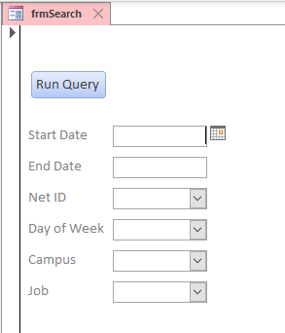

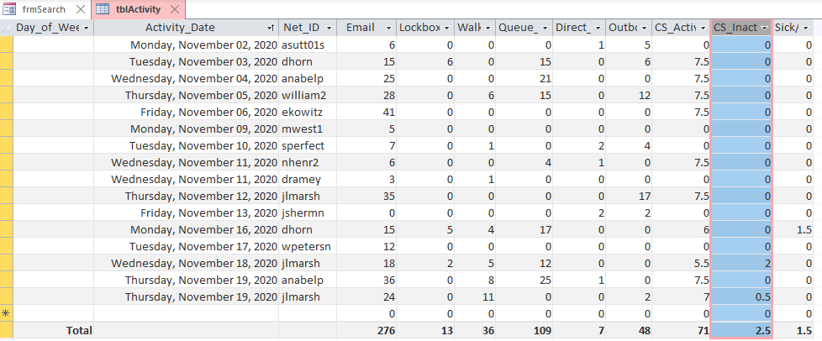

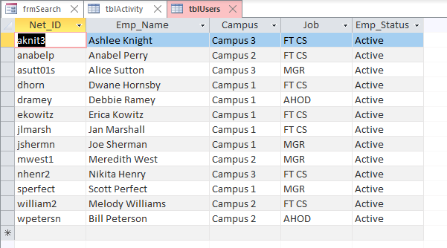

SELECT tblActivity.Activity_Date, DatePart("w",[Activity_Date]) AS DayOfWeek, tblActivity.Net_ID, tblUsers.Campus, tblActivity.Email, tblActivity.Lockbox, tblActivity.Walkin, tblActivity.Queue_Call, tblActivity.Direct_Call, tblActivity.Outbound_Call, tblActivity.CS_Active, tblActivity.CS_Inactive, tblActivity.[Sick/Vacation], tblUsers.Emp_Name
FROM tblUsers RIGHT JOIN tblActivity ON tblUsers.[Net_ID] = tblActivity.[Net_ID]
GROUP BY tblActivity.Activity_Date, DatePart("w",[Activity_Date]), tblActivity.Net_ID, tblUsers.Campus, tblActivity.Email, tblActivity.Lockbox, tblActivity.Walkin, tblActivity.Queue_Call, tblActivity.Direct_Call, tblActivity.Outbound_Call, tblActivity.CS_Active, tblActivity.CS_Inactive, tblActivity.[Sick/Vacation], tblUsers.Emp_Name;

